- Start the "Command Prompt" from the Windows Start Menu (Start -> Accessories -> Command Prompt).

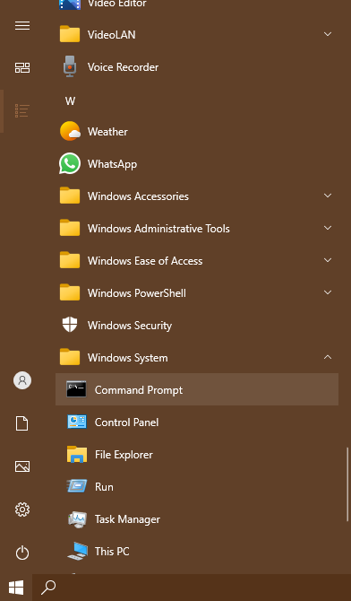

- Use cd, cd.., cd/.. commands to navigate through the directories.
Create the Directory HCK in the desktop.
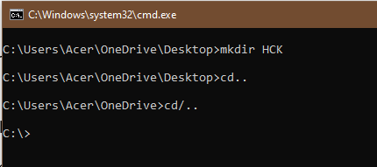

- List the files in the current directories. Make use of commands cls, exit to clear the screen and exit the prompt.
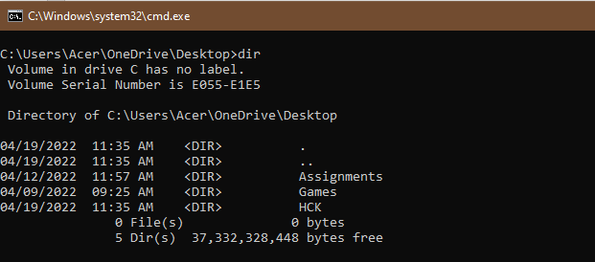
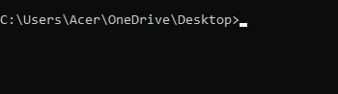
- Create New.txt file containing text “Herald College Kathmandu”, in the HCK directory.
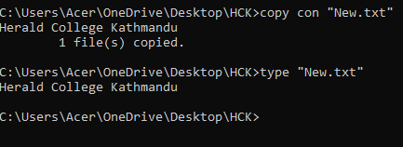
- Delete New.txt file from HCK directory.
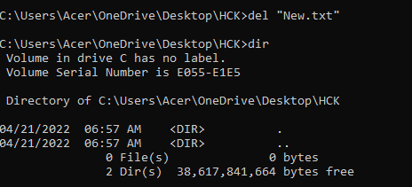
- Remove directory HCK form the Desktop.
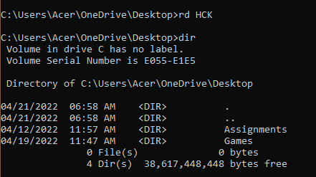
- Create directory Kathmandu in the desktop containing file Swyambhu.txt, rename Swayambhu.txt as Barahi.txt
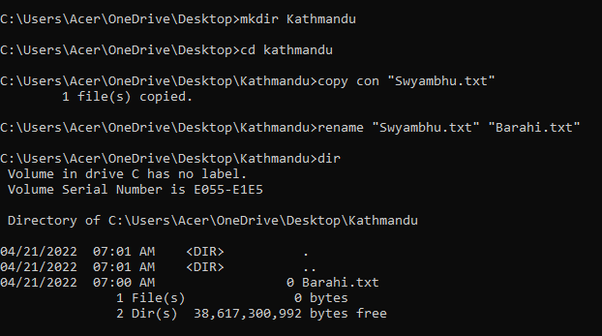
- Create Directory Pokhara in the Desktop and move Bahari.txt of directory Kathmandu in directory Pokhara.
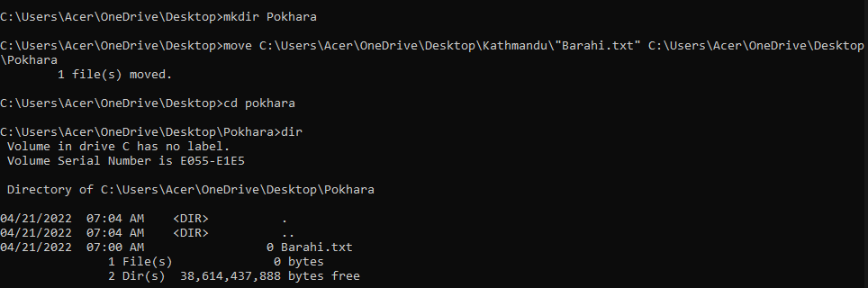

- Write the python program in IDLE which takes two inputs form the user and returns sum of the two number. Run this program from command prompt.
- Run the logsim program form the command prompt.
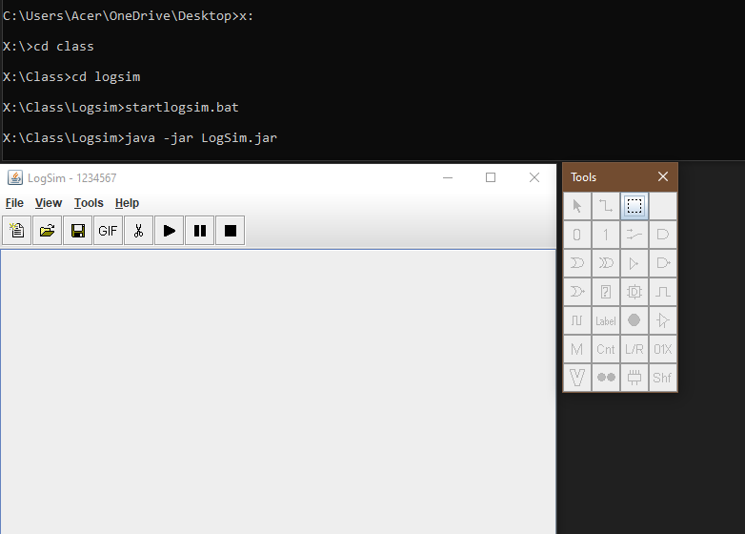

- Create the following structure and take Screen sort. Paste your result here.
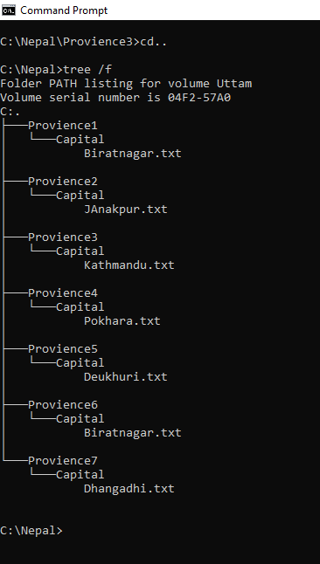

For more details about Commands you can type Help which lists all the internal commands:

